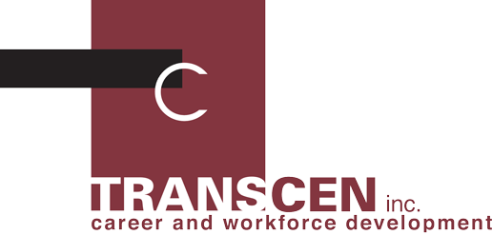
The Judith & William Borten Scholarship
About TransCen, Inc. (www.transcen.org)
TransCen, Inc. is a non-profit organization dedicated to improving educational and employment outcomes for youth with disabilities. Through this scholarship we honor founding TransCen Board members, Judith and William Borten, for their advocacy, dedication, and contribution to improving postsecondary outcomes for youth with disabilities.

Purpose of the Scholarship
In spite of key policy and legislative initiatives that address school-to-work transition for youth with disabilities, these youth continue to experience challenges as they prepare for postsecondary settings. Compounding this challenge is the nationwide shortage of special education teachers at the secondary level. Therefore, this Five Thousand Dollars ($5,000.00) scholarship will be awarded by TransCen to a college student who is preparing for a career in secondary special education in Maryland.

Eligibility
The Judith and William Borten Scholarship will be awarded to an undergraduate student who meets the following criteria:
- Current enrollment as a full time student at an accredited Maryland college or university;
- Commitment to a special education major, with an emphasis on secondary level education;
- Attainment of junior status and maintenance of at least a “B” average in major courses; and
- Intent to teach in a Maryland public school upon graduation.

Application Requirements
Applicants must submit the following:
- A completed application form (attached);
- An essay, no more than five double spaced typed pages that addresses why the applicant is interested in secondary special education, what qualifies the applicant for consideration for the award, and what are the career aspirations of the applicant in the secondary special education field. Discussion can include a description of the types of people with whom the applicant expects to work, and the applicants expected impact and contribution to the field;
- A copy of current transcripts or grade reports that verify current enrollment and GPA;
- A letter of reference from at least one college instructor that speaks to the applicant’s qualifications for the scholarship award; and
- Any other evidence of qualifications such as relevant awards, honors, or recognition.

Completed application packets are due April 30, 2017. Please send via mail to:
The Judith & William Borten Scholarship
c/o TransCen, Inc.
401 North Washington Street, Suite 450
Rockville, MD 20850

Applications must be received by April 30, 2017. Award decisions will be made by May 15, 2017.
Applicants will be notified by telephone and e-mail. For additional information, please contact: Darrell Burns at 240-778-9542.
This material is available in alternate format upon request

